Name: Riddhi Kankaria

Date: 8 July

Day : 1

\*Web application

1. user open browser enter url ....url contains https:// ...this sends request to DNS server

2. DNS server has a table and it maps domain name with ip address ....so from the request which it gets it gives respective ip address

3. now in a cloud or server there are computers with ip address connected to each other ...so whatever ip address server gets it shares that information

\* Detail functioning

1. http requests come to the web server and the web server passes these requests to a framework(Apache, tourcat,web brick etc) which uses languages such as python, java, csharp, ruby etc.

2. now web server does not cares what language is being used for coding

3. through these codes the request goes to that particular database

4. now database should be well organized so that it is easy to find the information we are looking for

\*Every web application make use of HTML,CSS and javascript.

1. HTML : text you see in browser

2. CSS : appearance of text

3. Javascript : interactions. to make java code more organize we use library such as angular, react, backbone

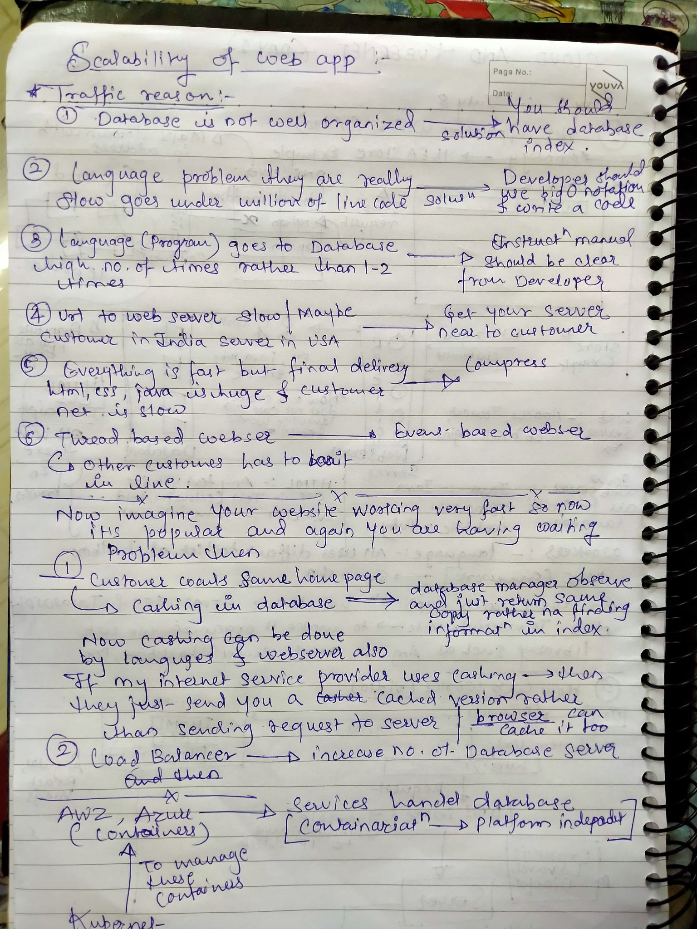

\*Network fundamentals:

1. Computers and other devices can connect to a network using cables or wireless medium.

2.cabled devices connect to a switch or router and wireless computers will connect to each other without an AP. This is called an AdHoc network

3. LAN- local area network = single building

4. WAN - wide area network = very large server